Digital Weight Scale System — Phase 1 Engineering Research & Component Selection
Prepared June 2026 · Draft for your review
Table of Contents

This document sets out our Phase 1 work on your digital weight scale system: the research, the engineering decisions, and the specific components we propose to build around. It covers every subsystem in your specification — the accuracy chain (load cells and ADC), the microcontroller, the junction box, the power and battery system, the communications, the displays, and calibration — and for each one I have given the reasoning and the actual parts, not just a general direction.
Nothing here is final; this is the engineering basis the detailed design will sit on. Where a requirement needed a judgement call, I have flagged it and explained why I went the way I did. The detailed schematics and PCB layout will be produced in KiCad.
A few decisions are baked into what follows and worth stating up front, because the rest of the design depends on them: I read “±0.01% accuracy” as 1 part in 10,000 of full scale (your own readability table confirms this — see §2); the “6 V battery” as a 2S LiFePO4 pack (6.4 V nominal), the proper drop-in for a 6 V lead-acid; and the 400 m wireless display as Wi-Fi + MQTT, per your direction. I have also taken the “do not use these ports” / “use SMD” note to mean no through-hole trimmer potentiometers anywhere — so corner adjustment is done digitally (§5). The system is built for India (230 V / 50 Hz mains).

1. System architecture overview
The whole product is best understood as one weighing indicator (the brain) plus a family of peripherals (junction box, displays) hanging off three transports: a wired RS-485 bus, a Wi-Fi/MQTT link for the wireless displays and the mobile app, and the wired analog/serial outputs. This keeps the five display variants and four junction-box variants from each needing their own design.
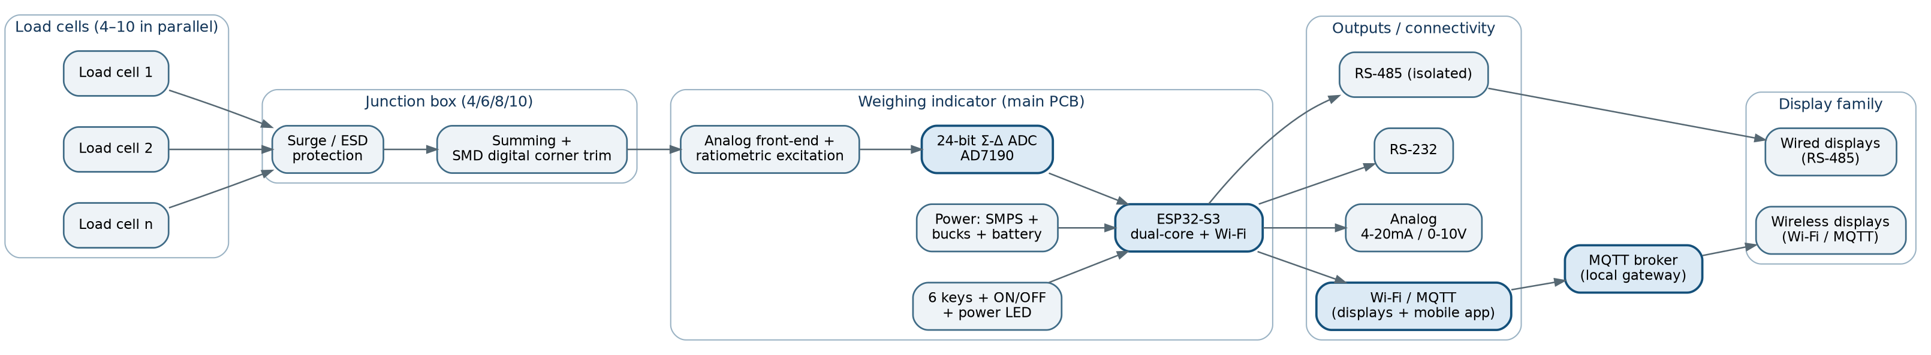
System architecture
The design rule that falls out of this: the indicator never “drives” a big LED display directly. The large 7-segment displays draw too much current (see §9) and sit far away, so they are independent units with their own power and their own small controller, fed only data — over Wi-Fi/MQTT for the wireless ones and RS-485 for the wired ones. This is what makes the 400 m wireless requirement and “any number of remote displays” practical.

2. The accuracy chain and error budget (the make-or-break section)
Everything else in this project is routine embedded design. The ±0.01% requirement is what makes this a precision-instrument job, so I have analysed it first and hardest.

2.1 What “±0.01%” actually means in counts
±0.01% = 1/10,000. A scale that is accurate to ±0.01% of full scale must resolve and hold 10,000 divisions. Your own platform table already encodes exactly this — the listed readability is, in almost every row, 1/10,000 of the capacity:
Platform | Capacity | Listed readability | 0.01% of capacity | Divisions implied
1×1 ft | 10 kg | 1 g | 1 g | 10,000
1×1 ft | 60 kg | 10 g | 6 g | 6,000
16″×16″ | 100 kg | 10 g | 10 g | 10,000
2×2 ft | 1000 kg | 100 g | 100 g | 10,000
3×3 ft | 3000 kg | 100–500 g | 300 g | 6,000–30,000
4×4 ft | 10,000 kg | 1 kg | 1 kg | 10,000
5×5 ft | 50,000 kg | 5 kg | 5 kg | 10,000
52×52 ft | 100 t | 10 kg | 10 kg | 10,000
So the design target is a clean, stable 10,000-count instrument (with headroom so the last count does not flicker). For context: 3,000 counts is an ordinary commercial scale (OIML Class III, C3 load cell); 10,000 counts sits at the top of Class III and brushes Class II. It is achievable, but it is a precision design.

2.2 Load-cell metrology — the bottleneck is mechanical, not electronic
A strain-gauge load cell’s resolving power is described by OIML R60 with two numbers the manufacturer guarantees:
- n_LC — maximum number of verification intervals the cell supports (C3 = 3,000; C6 = 6,000; some C-class cells are rated to 10,000).
- v_min — the smallest verification interval the cell can resolve (its real noise/repeatability floor, in mass units).
The governing rule for a multi-cell platform is e ≥ v_min · √N (equivalently v_min ≤ e / √N), where e is the scale division and N is the number of load cells. The √N penalty is the cost of paralleling cells: noise and tolerance add in quadrature, so a 4-cell platform needs cells with v_min at least 2× finer than the division you want, and a 10-cell platform needs about 3.2× finer.
Worked example (16″×16″, 300 kg, e = 30 g target ≈ 0.01%, 4 cells): required per-cell v_min ≤ 30 g / √4 = 15 g. A 300 kg-rated C3 cell (n_LC = 3,000) gives v_min of tens of grams, so a plain C3 cell is borderline-to-insufficient here. You either move to a higher class (C4/C6, finer v_min) or use fewer / lower-capacity cells closer to their rated load.
The honest headline: the load cell — not the ADC — is what limits this instrument. That is confirmed by real datasheets:
Cell (real part) | Class | mV/V | Combined error | Note
Flintec PC1-100kg | C3 | 2.0 | 0.02% FS | input 390 Ω, comp. temp −10…+40 °C
Flintec RC3-30t (rocker) | C3 | 2.0 | 0.02% FS | rated NTEP Class III 1:10,000, input 1150 Ω
Zemic L6D/L6E/L6G (single-point) | C3 | 2.0 | ~0.02% FS | low-cost workhorse for mini platforms
Note the tension: a standard C3 cell’s combined error is 0.02% — that is 2× the 0.01% target. It is listed as “1:10,000” for legal trade only because (a) legal maximum permissible error is graduated (±0.5 e at low load, ±1.5 e at the top) and (b) the load cell is apportioned only ~70% of that error (the OIML p_LC = 0.7 factor). So C3 at 10,000 counts is right at the edge.
How we actually hit ±0.01%:
- Two-point calibration (zero + deadweight span) removes the gain/span part of that 0.02%.
- Multi-point firmware linearization (e.g. 5-point) removes most of the nonlinearity component, which is the largest correctable error.
- What is left is hysteresis + non-repeatability (typically ~0.005–0.01% for good cells) plus temperature drift — that residual is the real accuracy floor.
- So: C3 cells + firmware linearization + ratiometric AD7190 + deadweight calibration gives ±0.01% of FS at reference temperature (≈20–30 °C). For a guaranteed ±0.01% across the full −10…+40 °C compensated band, I would specify C4/C6 cells for the platforms that matter (cost trade-off in §14).

2.3 The ADC requirement — and why the electronics are the easy part
Signal available per count, for a 2 mV/V cell: full-scale bridge output = 2 mV/V × V_exc; at V_exc = 5 V that is 10 mV full scale, so one count (1/10,000) = 10 mV / 10,000 = 1.0 µV per count.
To make a 10,000-count instrument rock-solid we want the ADC’s noise-free resolution several times finer than 1 µV. The Analog Devices AD7190 (24-bit Σ-Δ with integrated PGA, built for weigh scales) delivers rms noise of 8.5 nV at gain 128 / 4.7 Hz → 20.5 noise-free bits, and at a usable 50 Hz update rate, gain 128, rms noise ≈ 28 nV → 18.5 noise-free (peak-to-peak) bits.
Over our 10 mV signal that is roughly 54,000 stable counts available against the 10,000 we need — about a 5× electronic margin, at an update rate fast enough for live weighing. In other words, the electronics resolve ~5× finer than the best load cell can mechanically deliver, which is exactly the relationship you want: never let the converter be the bottleneck.

2.4 Ratiometric measurement (the single most important front-end trick)
The load cell output is proportional to its excitation (it is a ratiometric bridge). If we use the same excitation voltage as the ADC reference, any drift, noise or ripple on the excitation supply cancels exactly in the ratio. The AD7190 is designed for this — its reference inputs connect directly across the bridge excitation. So the excitation supply does not need to be ultra-precise (a low-noise LDO is enough), and a whole class of error (excitation drift over temperature and time) simply disappears. Mains hum is handled by the ADC’s digital-filter notch, set for 50 Hz rejection — correct for India’s 50 Hz supply.

2.5 Full system error budget (at reference temperature, post-calibration)
Error source | Typical contribution (% FS) | Correctable? | After correction
Load-cell nonlinearity (C3) | ~0.017% | Yes (multi-point linearization) | ~0.003%
Load-cell hysteresis (C3) | ~0.01–0.02% | No (mechanical) | ~0.01–0.02% (floor)
Load-cell non-repeatability | ~0.01% | No | ~0.01%
Load-cell span / zero | large | Yes (2-point cal) | ~0
ADC noise (AD7190, 50 Hz) | ~0.002% (1/54,000) | Averaging | <0.002%
ADC INL / gain drift | ~0.001% | Ratiometric + cal | negligible
Excitation drift | (cancels) | Ratiometric | ~0
Temperature (within comp. band) | ±0.0017%/°C span TC | Partly (TC comp.) | the wildcard
Bottom line: at reference temperature the error is dominated by load-cell hysteresis and repeatability, landing around ±0.005–0.015% with C3 and comfortably inside ±0.01% with C4/C6. The electronics contribute under 0.003%. This is the reason I want to spend the budget on load cells, not on a faster MCU.

2.6 The auto-calibration reality check
Your specification asks for “auto-calibration without weight standards” and “±0.01% accuracy.” It is important to say now, rather than at delivery, that these two cannot both be true at the same time.
Weightless (“electronic”) calibration — the technique behind Mettler-Toledo and Rice Lake CalFREE — computes the span from the load cell’s rated mV/V sensitivity and a factory-calibrated ADC. The industry documentation is explicit that this method calibrates the scale electronically only and is less accurate than test weights — suitable for an approximate calibration only. In practice it lands around 0.1–0.5%, i.e. 10–50× worse than your target.
What I recommend we build: implement both. Weightless auto-calibration for fast field setup and for tanks/silos where weights cannot be placed; and manual deadweight calibration with certified weights as the mode that actually reaches and verifies ±0.01%. The UI and manual will state clearly that ±0.01% is guaranteed only after deadweight calibration and that auto-calibration is an approximate mode. This matches how the professional indicators document it and protects us both from a “the scale isn’t 0.01%” dispute later.

3. Analog front-end and ADC selection

3.1 ADC comparison
ADC | Bits / type | Noise-free res. | Ratiometric | Gain | Verdict for this project
AD7190 (ADI) | 24-bit Σ-Δ, internal PGA | ~20.5 b @ 4.7 Hz, ~18.5 b @ 50 Hz | Yes | 1–128 | Primary choice. Lowest noise, built for weigh scales, ratiometric reference, channel sequencer.
AD7192 (ADI) | 24-bit Σ-Δ, PGA | ~11 nV rms (slightly noisier) | Yes | 1–128 | Pin-compatible cheaper alternate; use if AD7190 supply/cost is an issue.
ADS1232 / ADS1235 (TI) | 24-bit Σ-Δ | good, 2nd tier | Yes | 1–128 | Solid second source if dual-sourcing ADI is a concern.
NAU7802 (Nuvoton) | 24-bit | mid | partial | up to 128 | Cheap, I²C, OK for the mini platform only.
HX711 | 24-bit | ~13–15 noise-free bits in practice | No (internal reg) | 32/64/128 fixed | Rejected for the main instrument. Fine for a 3,000-count scale; its noise, fixed gains and temperature drift make a guaranteed 10,000-count instrument across temperature unreliable.
Decision: AD7190 on the indicator PCB, SPI to the ESP32-S3, gain 128, sinc4 filter with the 50 Hz notch, ratiometric reference across the bridge excitation. I will lay the footprint so the AD7192 also fits, as a cost-down option.

3.2 Front-end signal path
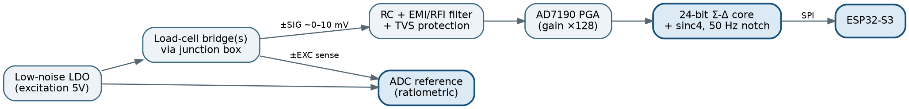
Analog front-end signal path
Things in this path that protect the accuracy:
- 6-wire (sense) connection to the bridge so cable resistance and temperature do not corrupt excitation; the sense lines feed the ratiometric reference.
- EMI/RFI input filtering (matched RC + common-mode choke) at the signal inputs — weigh-scale front-ends pick up RF, so this is not optional.
- TVS / clamp diodes on signal and excitation against ESD and field surges (these cables can be long).
- A quiet analog ground island, single-point tied to digital ground, with guarded high-impedance signal traces.

3.3 A note on the mains supply (India)
India’s mains is 230 V / 50 Hz (the spec’s “220 VAC” sits inside the Indian 220–240 V band). I will use a universal-input SMPS so the unit tolerates Indian supply variation, and the ADC’s digital filter is set to the 50 Hz notch, which is correct here.

4. Microcontroller selection (ESP32 family)

4.1 Why ESP32-S3
Variant | Cores / speed | Wireless | I/O & peripherals | Fit
ESP32 (classic) | 2× 240 MHz | Wi-Fi 4 + BT/BLE | plenty | Works, but older silicon.
ESP32-S3 | 2× 240 MHz (LX7) | Wi-Fi 4 + BLE 5 | ~45 GPIO, 4× SPI, 3× UART, 2× I²C, RAM + PSRAM | Selected. Best balance: enough peripherals for ADC + RS-485 + RS-232 + DAC + keypad + local display, and on-chip Wi-Fi for MQTT and the mobile app.
ESP32-C6 | 1× 160 MHz RISC-V | Wi-Fi 6 + BLE + 802.15.4 | fewer | Good radios but single-core and pin-tight for this many buses.
ESP32-P4 | 2× 400 MHz RISC-V | none (needs companion radio) | rich | Overkill on compute and no built-in radio — wrong tool.
The job is peripheral-bound, not compute-bound: the hard work (the Σ-Δ conversion and filtering) happens in the AD7190, so we do not need the P4’s horsepower. We need plenty of I/O and on-chip Wi-Fi for the MQTT link to the wireless displays and the mobile app — which makes the ESP32-S3 the correct pick. Because the wireless displays now run over Wi-Fi/MQTT (§9), there is no separate radio module to add.
Recommended module: ESP32-S3-WROOM-1-N16R8 (16 MB flash, 8 MB PSRAM) — a pre-certified module that saves us the 2.4 GHz RF compliance work (it should carry WPC/ETA approval for sale in India).

4.2 Peripheral / pin budget (proof it fits)
Function | Bus | Notes
AD7190 ADC | SPI1 | + DRDY/CS GPIO
Wi-Fi (MQTT + mobile app) | on-chip | no pins used
RS-485 | UART1 + DE/RE GPIO | isolated transceiver
RS-232 | UART0 | MAX3232
Analog out DAC | SPI or I²C | AD5421 / MCP4922
Calibration EEPROM (backup of NVS) | I²C | + on-chip NVS in flash
Local display (LCD HT1622 / 7-seg driver) | I²C or SPI | shared bus
6 function keys + ON/OFF | 7× GPIO (or matrix) | with RC debounce
Power LED + status LEDs | 2–3× GPIO
Soft power / load-switch control | 1× GPIO | latching power (§10)
Mains-present / battery-status sense | 2× ADC GPIO | auto power-path + low-battery warning
Comfortably within the S3’s pin count, with a UART freed now that there is no external radio.

5. Junction box design (4 / 6 / 8 / 10 cells)

5.1 The trimmer-pot constraint changes the topology
Your “Don’ts” image is a tray of blue through-hole multi-turn trimmer potentiometers, with “do not use these” and “use every component in SMD.” In a classic analog junction box those trimpots are exactly how corner adjustment (making each cell read the same for an off-centre load) is done. That method is now ruled out, so I will use one of two compliant approaches:
Option A — analog summing + digital corner trim (recommended, cost-effective): cells are summed in parallel as usual, but each cell’s gain is trimmed by an SMD non-volatile digital potentiometer (e.g. AD5142A) controlled by the indicator over I²C. Corner calibration becomes a menu function (place a known weight on each corner, the indicator nudges the digipot) — no screwdriver, no through-hole parts, all SMD, and the trim survives power-down in the digipot’s EEPROM.
Option B — per-cell digitization + firmware summing (highest accuracy): each cell (or each pair, via an SMD analog mux such as ADG1607) is read individually by the ADC’s channel sequencer; the indicator sums them in firmware with a per-cell calibration coefficient. No analog trim at all — corner calibration is pure software, and it gives the best accuracy plus per-cell diagnostics (it can detect a single failing or disconnected cell, which also satisfies the optional “don’t allow calibration if a cell is faulty/disconnected” requirement). It costs more channels/mux and firmware effort.
My recommendation: ship Option A as the standard junction box (cheap, all-SMD, compliant) and offer Option B as the premium/diagnostic variant for high-cell-count heavy platforms.

5.2 Junction-box block diagram
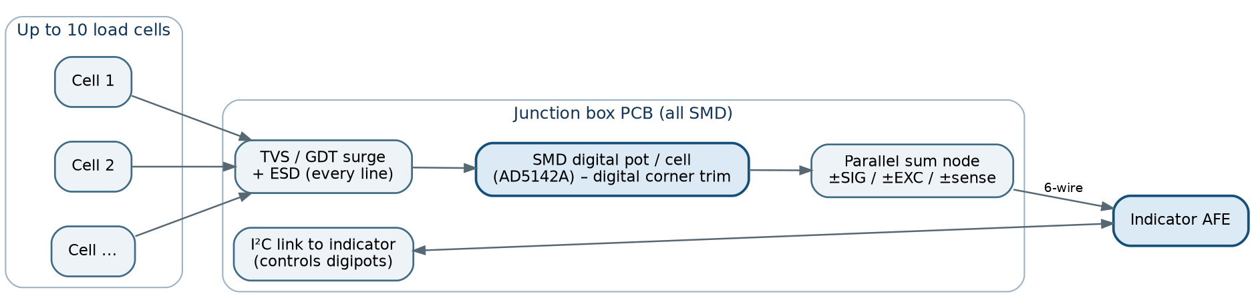
Junction box

5.3 Common requirements for all four variants
- Same PCB family, populated for 4/6/8/10 cells (depopulate channels for smaller boxes) — one design, four BOMs.
- 6-wire pass-through (sense lines) to preserve ratiometric accuracy on long runs.
- Per-line gas-discharge tube + TVS surge protection (field cabling sees lightning-induced and static surges).
- Conformal-coated, IP-rated enclosure; cable glands sized per variant.
- On high-cell-count platforms, use 700–1000 Ω cells (not 350 Ω) to keep excitation current sane (see §7 budget).

6. Power system (mains + battery backup)

6.1 Topology
Power system topology

6.2 Why this topology
- Diode-OR (ideal-diode) power path: with mains present, the 12 V rail (higher voltage) powers the bucks and the charger tops up the battery; when mains fails, the 6.4 V battery seamlessly takes over the buck inputs (the bucks accept ~5.5–15 V). No relays, no glitches. I will use an ideal-diode controller (LM74700-Q1 / LTC4412) rather than plain Schottkys to avoid the 0.3–0.5 V drop and heat.
- Separate analog rail: the AD7190 and bridge excitation are fed from a low-noise LDO (ADP7142 / TPS7A47) downstream of the 5 V buck, so switching ripple never reaches the µV-level analog path.
- Universal-input SMPS + EMI filter + MOV + fuse on the AC inlet — mandatory for a mains product, and it also keeps conducted noise out of the ±0.01% measurement.

6.3 Recommended power parts
Block | Recommended part(s) | Why
AC-DC SMPS 12 V | Mean Well IRM-20-12 / IRM-30-12 (PCB-mount, universal input) | Certified module shortcuts safety/EMC; spec already mandates SMPS.
12 V→5 V buck | TPS54331 / LMR33630 | Cheap, SMD, wide-Vin, handles excitation + display load.
12 V→3.3 V buck | LMR33630 / TPS562 | Logic + Wi-Fi rail.
Analog LDO | ADP7142 / TPS7A4700 | Ultra-low-noise for excitation/reference.
Ideal-diode OR | LM74700-Q1 / LTC4412 | Lossless power path.
Charger | CN3768 (LiFePO4) / LTC4015 | CC/CV, programmable.

7. Battery and BMS — chemistry, sizing, and runtime

7.1 Chemistry comparison (against the “6 V” requirement)
Chemistry | Pack for ≈6 V | Nominal V | Cycle life | Safety | Drop-in for “6 V”? | Verdict
LiFePO4 (LFP) | 2S | 6.4 V | ~2,000–2,500 | Excellent (no thermal runaway) | Yes — sold as a 6 V SLA replacement | Selected
Sealed lead-acid (SLA) | 3 cells | 6.0 V | ~300–500 | Good | n/a (the original) | Heavy, short life, only ~50% usable — the thing we are replacing
Li-ion (NMC) | 2S | 7.4 V | ~500–1000 | Moderate (runaway risk) | No — 7.4 V ≠ “6 V” | Wrong voltage and worse safety
Li-polymer | 2S | 7.4 V | ~300–500 | Moderate | No — 7.4 V | Same problem; pouch format unsuitable for industrial
Why 2S LiFePO4 wins: it is the only lithium chemistry whose nominal voltage (6.4 V, range ~5.0–7.2 V) actually matches “6 V”; it is the safe choice for an industrial product (LiFePO4 does not go into thermal runaway the way Li-ion/LiPo can); it tolerates near-100% depth of discharge (vs ~50% for SLA); and it lasts 5–8× more cycles than SLA. It is sold as a 6 V SLA drop-in (e.g. the 6.4 V 4.5 Ah LFP modules with integral protection, rated ~2,500 cycles).

7.2 Power budget (indicator on battery, Wi-Fi/MQTT active, mini platform)
Because the wireless displays now run over Wi-Fi/MQTT, the indicator keeps its Wi-Fi associated and publishing in normal use — which draws more than a sleepy dedicated radio would. The budget reflects that:
Block | Rail | Current | Power
ESP32-S3 + Wi-Fi (associated, MQTT publishing, modem-sleep) | 3.3 V | ~85 mA | ~280 mW
AD7190 ADC | 5 V (analog) | 4.4 mA | ~22 mW
Load-cell excitation (1× 390 Ω @5 V, mini) | 5 V | 12.8 mA | ~64 mW
RS-485 transceiver (idle/RX) | 5 V | ~2 mA | ~10 mW
RS-232 transceiver | 3.3 V | ~5 mA | ~17 mW
Local LCD (HT1622 + green backlight) | 3.3 V | ~8 mA | ~26 mW
EEPROM / I²C / misc | 3.3 V | ~3 mA | ~10 mW
Power + status LEDs | 3.3 V | ~15 mA | ~50 mW
System subtotal (rails) |  |  | ≈ 0.48 W
With margin for Wi-Fi bursts and a brighter display, I design to ≈ 0.7 W at the rails. Through the bucks (η ≈ 88%) that is ≈ 0.8 W, i.e. ≈ 125 mA from a 6.4 V pack.

7.3 Runtime
Runtime = usable Ah / pack current; LiFePO4 usable ≈ 90% of rated.
Pack | Usable Ah | Wi-Fi off (local display only, ~0.45 W ≈ 70 mA) | Typical, Wi-Fi + MQTT (~0.8 W ≈ 125 mA) | Heavy (10-cell + Wi-Fi + bright, ~1.7 W ≈ 266 mA)
2S 3 Ah | 2.7 | ~38 h | ~22 h | ~10 h
2S 4.5 Ah | 4.05 | ~58 h | ~32 h | ~15 h
2S 6 Ah | 5.4 | ~77 h | ~43 h | ~20 h
Recommendation: a 2S LiFePO4 6.4 V, 4.5–6 Ah pack, giving ~1.3–1.8 days of backup at typical (Wi-Fi-on) load. Two useful levers: on high-cell-count platforms use 700–1000 Ω cells to cut excitation current; and on a mains-loss event we can automatically drop Wi-Fi (keeping only the local display alive), which roughly doubles backup time if the remote displays have their own power. Final capacity to be locked once you confirm the worst-case configuration that must run on battery.

7.4 BMS and charging
- BMS (2S LiFePO4): per-cell overcharge cutoff 3.65 V, over-discharge cutoff ~2.0–2.5 V, overcurrent + short-circuit protection, and passive balancing during charge. For a product I would put an integrated AFE (e.g. BQ77216 / BQ769x) on our own PCB, which also gives a fuel-gauge readout to the MCU.
- Charge profile: CC/CV, CV = 7.2 V (3.6 V/cell), charge current ~0.2–0.5C (≈1–2 A for a 4.5 Ah pack), empty→full ≈ 3–4 h. Charger fed from the 12 V SMPS rail; BMS handles balance + protection.
- MCU integration: feed mains-present and pack voltage / fuel gauge into the ESP32-S3 so the display shows a battery icon, warns on low battery, and logs mains-loss events.
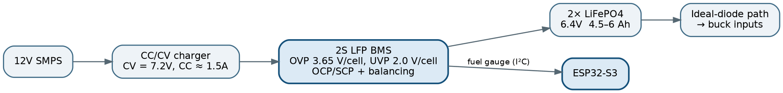
Battery and charge path

8. Communications (RS-485, RS-232, analog output)
Interface | Recommended part | Notes
RS-485 | ADM2587E / ADM2582E (isolated), or THVD1450 (non-isolated) | Use the isolated transceiver for industrial robustness; half-duplex multidrop, ideal for the wired remote-display bus and PLC connection. Terminate 120 Ω at both ends.
RS-232 | MAX3232 (SMD) | Legacy point-to-point to PCs / older PLCs.
Analog output | AD5421 (16-bit loop-powered 4–20 mA DAC), + an op-amp stage for 0–10 V | Weight re-transmitted as an analog signal, scalable from the menu (e.g. 4 mA = 0, 20 mA = capacity). 4–20 mA is preferred for noise immunity over long runs.
The wireless display path is Wi-Fi/MQTT, covered in §9.
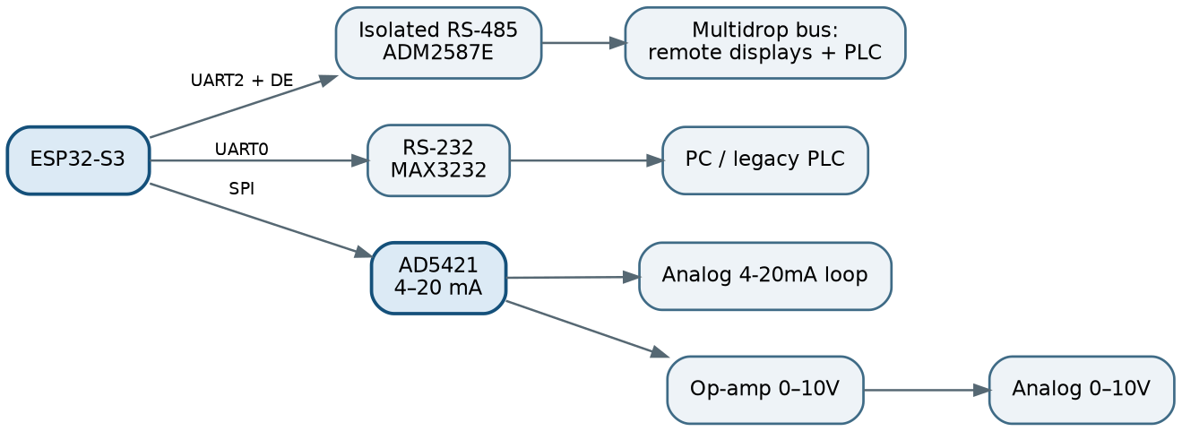
Wired communications

9. Display family

9.1 One architecture, all five variants
All five listed displays reduce to two transports × two display technologies: Wi-Fi/MQTT or RS-485, carrying either 7-segment LED or character LCD/OLED.
# (your spec) | Size / type | Digits | Transport | Keypad? | How we build it
1 | 1″ 7-seg, red/green | 6 | Wireless (Wi-Fi/MQTT) + Wired | (main has keypad) | bicolor LED + driver + ESP32-C3 (Wi-Fi/MQTT) or RS-485 receiver
2 | 4″ 7-seg, red/green | 6 | Wireless (Wi-Fi/MQTT) + keypad | yes | large bicolor LED + constant-current driver + higher rail + ESP32-C3
3 | 1.25″ LCD, green-on-black | 8 chars | Wired (extra) | no | HT1622 + custom negative LCD (or green OLED) + RS-485
4 | 2″ LCD, green-on-black | 8 chars | Wired (extra) | no | same as #3, larger glass
5 | 0.5″ 7-seg, red/green | 6 | Wired (extra) | no | small bicolor LED + driver + RS-485

9.2 Driver recommendations
- 7-segment LED (1″, 4″, 0.5″, “red/green”): “red/green” = bicolor (common-anode) digits; firmware sets colour by state (green = stable/in-range, red = motion/overload/error). Drive with constant-current LED drivers (MAX6954/MAX6958 for the small ones; MBI5024 / TLC5940 current sinks for the big 4″ digits). The 4″ digits stack multiple LED dies per segment → ~9–12 V per segment, so that display unit carries its own boost/dedicated rail — another reason the big displays are independent powered units, not driven from the indicator.
- LCD “exactly 8 characters, green on black, best option”: my recommendation is a custom 8-digit negative-mode (transflective) segment LCD driven by an HT1622 (the de-facto scale LCD driver — ultra-low power, sunlight-readable) with a green LED backlight for the black-background/green-digit look. The alternative is a green character OLED module (sharper, wider viewing angle, but higher power and a finite lifetime). I would default to HT1622 + negative LCD for power and longevity, and offer OLED as a premium option.

9.3 Each remote display is a small slave unit
Each remote display — wired or wireless — is its own small PCB: a low-cost MCU (an ESP32-C3 for the Wi-Fi/MQTT ones, or just a display driver behind an RS-485 transceiver for the wired ones) plus its own power (a mains adapter for the big LEDs; a small adapter/battery for the LCDs). It receives a weight message and renders it. This is what makes “any number of displays” and the 400 m wireless reach practical, and it keeps the indicator’s own power budget clean.
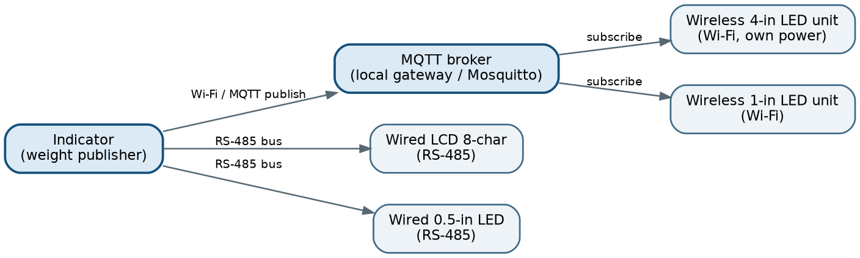
Display network

9.4 The 400 m wireless link — Wi-Fi + MQTT
Per your decision, the wireless displays talk to the scale over Wi-Fi using MQTT, not a dedicated radio. The scale’s ESP32-S3 has Wi-Fi on-chip, so there is no extra radio module to add to the BOM.
Architecture. The indicator is an MQTT publisher: it pushes the live weight (plus unit, gross/net, stability flag, status) to an MQTT broker, and every remote display is a subscriber that renders whatever it receives. The optional mobile app subscribes to the same broker, so the displays and the app share a single transport — one of the real advantages of going this route.
Broker. Two options, and I would let the site dictate which: (a) a lightweight broker such as Mosquitto on a small local gateway / industrial PC — my default, because it is reliable and keeps the scale’s CPU free; or (b) the scale itself acting as a Wi-Fi access point running an embedded broker, for a fully self-contained system where there is no site network.
Topic and payload. A topic like scale/<id>/weight carrying a compact JSON message ({w, unit, stable, net, ts}). I will use QoS 1 for guaranteed delivery, a retained message so a display that joins late immediately shows the last weight, and an MQTT last-will so a display can show “link lost” if the scale drops off the network.
The “with switch” requirement. This becomes a device/topic selector on each display — a DIP switch or menu setting that chooses which scale ID / topic the display follows — so several scales and many displays can coexist on one network.
Update rate. Publishing a few times per second over Wi-Fi gives sub-second display updates, which is right for live weighing.
Range — the one practical caveat. A bare module’s Wi-Fi will not span 400 m on its own; that distance is covered by the site Wi-Fi — access-point placement, a repeater/mesh, or a directional/high-gain antenna on the scale’s access point. So 400 m here is a coverage/infrastructure question, not a chip limitation. For a guaranteed long reach we can fit an external high-gain antenna on the scale and/or use an outdoor AP. The trade-off versus a dedicated long-range radio is simply that Wi-Fi needs coverage to be planned; in return you get standard tooling, trivially many displays, and the mobile app on the same link.

10. Keypad, power control, and UI
- 6 function keys + 1 ON/OFF + power LED (exact spec). The six keys go to GPIO (direct or 3×2 matrix) with RC + firmware debounce.
- ON/OFF is soft latching power, not a hard switch: the ON/OFF key drives a load-switch / P-FET + latch so the MCU can come up cleanly, perform a graceful shutdown (saving calibration/tare to NVS), and auto-power-off on low battery. This avoids corrupting calibration data on a hard cut.
- Power indicator LED plus spare status LEDs — the spec’s separate SMPS-indicator, SMPS-to-PCB and “big indicator” LEDs map here.
- Menu-driven UI with password protection (menu-based access control): a PIN stored in NVS/EEPROM gates the calibration and configuration menus. The final UI layout is frozen at the end of the development phase, as your spec requests.

11. Firmware feature notes
- Auto-zero / zero-tracking (the “2-second” rule): a slow zero-tracking loop. If the reading is within the configurable band (your 30 kg / 50 kg “limit”) and stable for 2 s, re-zero; if the load exceeds the limit, freeze so a real weight is not zeroed away.
- if |reading - zero| < limit AND stable_for(2s):
zero = reading # auto-zero
else if |reading - zero| >= limit:
hold_display() # do NOT track; show stable weight
- “Stable” = variation under a few divisions over a sliding window — this is also the motion/no-motion flag that drives the green/red display colour and gates printing/analog hold.
- MQTT client over Wi-Fi: publishes live weight to the broker for the wireless displays and the mobile app (QoS 1, retained, last-will), with auto-reconnect.
- Digital filtering: the AD7190’s sinc4 filter does the heavy lifting; firmware adds light moving-average plus the motion detector, balancing settling time against noise.
- Calibration data + tare stored in NVS with a redundant I²C EEPROM copy and CRC, so a brown-out never loses calibration.
- Faulty/disconnected-cell detection (your optional requirement): with Option-B per-cell reading this is detected directly; with Option-A we watch for out-of-range bridge voltage / sense-line loss. The calibration menu is blocked when a cell is faulty or disconnected, as requested.

12. Calibration strategy
- Manual deadweight calibration (the accuracy path): zero + one or more certified-weight span points; this is the only way to reach and verify ±0.01%. Add multi-point linearization (e.g. 5 points) to knock down load-cell nonlinearity.
- Weightless / auto calibration (the convenience path): compute span from rated mV/V + the calibrated ratiometric ADC; documented as approximate (~0.1–0.5%), for setup and tanks only.
- Corner / section calibration: digital (digipot in Option A, or per-cell coefficient in Option B) — no trimpots.
- Temperature handling: specify load cells within the −10…+40 °C compensated band; optionally add an on-board temperature sensor and a span-TC correction table for the wider operating range.

13. Compliance and safety notes (for India)
- Mains side: fuse + MOV + X/Y caps + reinforced isolation from the SMPS; proper creepage/clearance on the PCB. The unit runs on India’s 230 V / 50 Hz with a universal-input SMPS.
- EMC: input EMI filter, shielded/guarded analog front-end — needed both for compliance and to hold ±0.01% in a noisy industrial environment.
- Radio: the 2.4 GHz Wi-Fi band is licence-exempt (de-licensed) in India; the ESP32-S3 module should carry WPC/ETA approval for sale and import.
- Battery: LiFePO4 + a proper BMS, with UN38.3 transport considerations for the finished pack.
- Legal-for-trade: if the scale must be legal-for-trade in India, that is a separate certification path under the Legal Metrology Act (model approval, sealed calibration, graduated error limits). The spec does not ask for it explicitly — please confirm whether it is in scope, because it changes load-cell selection and the calibration-lock design.

14. Preliminary key-component BOM
These are the parts the rest of the design hangs on. Detailed schematics and PCB layout will be delivered as KiCad projects.
Subsystem | Recommended part | Alternate / cost-down | Driving requirement
MCU module | ESP32-S3-WROOM-1-N16R8 (on-chip Wi-Fi → MQTT + app) | ESP32-S3-WROOM-1-N8 | I/O count + Wi-Fi for MQTT
Weigh ADC | AD7190 | AD7192 (pin-compat), ADS1235 | 10,000-count, ratiometric, low noise
Analog LDO (excitation/ref) | ADP7142 | TPS7A4700 | low-noise ratiometric supply
Load cells — mini (10/60 kg) | Zemic L6D/L6E or Flintec PC1 (C3) | upgrade to C4 for margin | single-point, off-centre tolerant
Load cells — medium/heavy | Flintec RC3 / shear-beam (C3), 700–1000 Ω | C6 where ±0.01% must be guaranteed | √N + excitation-current budget
Junction-box trim | AD5142A digipot (SMD) | per-cell mux ADG1607 (Option B) | no trimpots, all SMD
Wireless display transport | ESP32-S3 on-chip Wi-Fi + MQTT | — | 400 m via site Wi-Fi
Remote display controller (MQTT subscriber) | ESP32-C3 (Wi-Fi) | — | wireless display unit
MQTT broker | Mosquitto on a local gateway | embedded broker on scale SoftAP | publish/subscribe hub
RS-485 | ADM2587E (isolated) | THVD1450 | industrial multidrop
RS-232 | MAX3232 | — | legacy link
Analog out | AD5421 (4–20 mA) + op-amp for 0–10 V | DAC8551 + XTR111 | analog signal mode
LCD driver | HT1622 + negative LCD + green backlight | green character OLED | 8-char green-on-black
7-seg driver (small) | MAX6954/MAX6958 | — | bicolor 6-digit
7-seg driver (4″) | MBI5024 / TLC5940 + boost rail | — | high-current big digits
AC-DC SMPS | Mean Well IRM-20-12 / IRM-30-12 (universal input) | custom flyback | 230 VAC → 12 V, certified
Bucks | LMR33630 (5 V, 3.3 V) | TPS54331 | rail generation
Ideal-diode OR | LM74700-Q1 / LTC4412 | — | lossless mains/battery path
Charger | CN3768 (LiFePO4) / LTC4015 | — | CC/CV 7.2 V
BMS | BQ77216/BQ769x + balancing | off-the-shelf 2S 10 A LFP PCM | safety + balance + gauge
Battery | 2S LiFePO4 6.4 V, 4.5–6 Ah | 6 V SLA (legacy/cost) | “6 V” backup, long life
Protection | TVS + GDT on cell/comm lines; MOV + fuse on AC | — | field surge/ESD survival

15. What I need from you to start the detailed design
In rough priority order:
- Confirm the accuracy interpretation: is “±0.01%” = 1 part in 10,000 of full scale at reference temperature after deadweight calibration? If you need it held across the full −10…+40 °C range, we budget for C4/C6 cells and the cell cost rises.
- Is legal-for-trade / Legal Metrology model approval in scope? This changes load cells, the calibration lock, and adds cost and time.
- Worst-case battery configuration: which display(s) and how many load cells must keep running on battery? This locks the pack capacity (§7.3).
- Site Wi-Fi for the wireless displays: is there (or will there be) Wi-Fi coverage across the 400 m working area, and do you want the MQTT broker hosted on a site gateway or on the scale’s own access point? This drives the antenna/AP plan.
- Junction box: Option A (analog + digital trim, cheaper) or Option B (per-cell digitization, best accuracy + cell diagnostics) — or A as standard and B as a premium variant, as I propose.
- LCD technology: HT1622 + negative LCD (my default) or green OLED?
- Quantities and target unit cost — this drives the C3-vs-C6, isolated-vs-non-isolated, and module-vs-discrete choices throughout the BOM.

16. Sources consulted
Full datasheets will be archived in the project repository.
- Precision ADC: Analog Devices AD7190 / AD7192 datasheets and weigh-scale circuit notes (CN-0102 / AN-2506) — noise figures (8.5 nV rms @ 4.7 Hz → 20.5 noise-free bits; ~18.5 bits @ 50 Hz), ratiometric weigh-scale front-end, radiated-immunity guidance.
- Load-cell metrology: OIML R60 (verification intervals, v_min, the e ≥ v_min·√N rule); Flintec PC1 / RC3 datasheets (2 mV/V, 0.02% combined error, RC3 rated NTEP Class III 1:10,000); Zemic single-point cell catalogue.
- MCU: Espressif ESP32 family material and 2026 selection guides (S3 = best peripheral/radio balance; P4 has no radio; C6 single-core/fewer pins).
- Wireless: ESP32-S3 on-chip Wi-Fi with MQTT (e.g. a Mosquitto broker; MQTT QoS, retained messages and last-will).
- Battery / BMS: 2S LiFePO4 (6.4 V) products marketed as 6 V SLA drop-ins (~2,500-cycle life, integral BMS); 2S LFP BMS/PCM specs (OVP 3.65 V/cell, UVP ~2.0 V/cell, 7.2 V charge, passive balancing).
- Calibration: Mettler-Toledo / Rice Lake CalFREE documentation — weightless calibration is electronic-only and explicitly less accurate than test weights / approximate only.

This is the analysis the build decisions will sit on; none of it is locked. Tell me which sections you would like expanded next — for example a full schematic-level front-end, a per-platform load-cell selection table for all eight platforms, or a detailed firmware state machine — and I will take it deeper.

